Bullying, Violence, and Perception of Safety:
Alabama Students in Grades 6-12, 2003 – 2005

ABSTRACT

The safety of the school environment has long been linked to positive academic achievement and the overall wellbeing of the students, teachers, volunteers, and administrators who report to a school campus daily. Beginning in 2003, Alabama began surveying its middle and high school students in an effort to determine student levels of substance use and dangerous behaviors.

This report provides an analysis of data from the most recent survey (spring 2005) of 263,954 students in grades 6-12 and compares findings to data from previous years (2003 and 2004), as well as to the Pride Surveys national dataset. Also, trend data comparisons of the larger ethnic groups, White, Black and Hispanic, are reported

While Alabama students reported some signs of improved perceptions of safety between 2003 and 2005, other survey data suggest that Alabama students are feeling less safe in their schools. Compared to their peers across the nation, Alabama students appeared to be more afraid of being at school and reported more involvement in gang activities and bringing weapons to school.

With research indicating that fear decreases academic achievement, the survey results point to the need for a continuation of present programs in prevention of violence, threatening behaviors (bullying) and related behaviors. Additional violence prevention and safety programs may be needed to allay student fears. It is hoped that this report can assist in focusing efforts to address violence, bullying, and fear relating to students’ perception of safety in their school environment.

Report prepared for the Alabama Department of Education by Pride Surveys, 160 Vanderbilt Court; Bowling Green, Kentucky 42103; 800 279 6361. January 2006.

© 2006. Pride Surveys.
TABLE OF CONTENTS

Introduction 3
Research: Academic Achievement and Violence 3

Methods Used for the Alabama Surveys 4
Core Measures of Violence 4
Study Population 4
Pride Questionnaire and Other Methods 4

Key Findings 4
Gang Participation / Gang Membership 4
Carrying Guns 5
Guns at school 5
Guns outside of school 6
Threatening Behaviors 7
Fear of Being Hurt at School 8
Being Hurt at School by Another Student 8
Safety and Fear 9
The influence of ethnicity 10
Conclusion 11

Appendix: Study Population and Pride Surveys National Dataset
INTRODUCTION

For the past three years (2003, 2004, 2005), the Alabama Department of Education, in collaboration with the Alabama Department of Mental Health and the Alabama Department of Economic and Community Affairs, has administered the Pride Questionnaire for Grades 6-12 to Alabama students, conducting a statewide population survey of student behaviors involving substance use, violence, and related behaviors. The Pride Survey has given Alabama a wealth of information on students’ perceptions of violence, bullying, and safety in their schools and communities, and how those factors have changed over time.

This report, based on the three Alabama surveys, explores variables related to violence and bullying, including: trends in threatening behaviors; students carrying guns at school and outside of school; gang activity; and students’ perceptions of how often they feel safe in specific areas of their schools. The Alabama data are compared to data from the Pride Surveys national dataset, and are presented for the most prevalent subgroups in the state: White, Black and Hispanic students.

Research: Academic Achievement and Violence

When a dramatic, violent episode occurs in the school environment, the attention it receives in the news media adds to the discomfort and fear of the children and teachers who are part of the school environment anywhere in the nation. The thought of a child or teacher being physically hurt at school is upsetting and drives action for better violence prevention programs and policies.

While severely violent incidents must be prevented, research has demonstrated that even small incidents and an atmosphere of fear are enough to affect children emotionally and academic achievement adversely. In a recent article on early childhood violence, Massey cited four studies and concluded “chronic exposure to violence adversely affects a child’s ability to learn.”¹

In another study, Heinrich et al found that a review of the literature suggested a negative correlation between violence exposure and academic achievement.² Heinrich believes this correlation indicates that children who report more instances of witnessing and victimization by violence, whether in the school, home, or community, do not perform as well in school as their peers reporting fewer instances.

A report produced by the Massachusetts Advocates for Children suggests a cause for this observed correlation, in the context of children affected by domestic and family violence. This report by Cole et al found that “when children live in a constant state of fear, the areas of their brains controlling the fear response can become overdeveloped ….It is important to note that the areas of the brain active in fearful states are different from those active in calm states, and it is predominantly the areas active in calm states that are required for academic learning.”³ A student worrying about being attacked in the parking lot will not be functioning well at tasks required in the classroom.

Even children who are not directly affected by violence may still have to deal with its aftermath. Lorion’s research indicates that “widespread concern about violence within a school may reduce the quality of teaching, disrupt classroom discipline, limit teachers’ availability to students before or after the school day, and reduce students’ motivation to attend school and/or willingness to participate in extracurricular activities.”⁴

In any discussion of academic achievement, administrators, educators, and parents should be aware of the need to improve students’ confidence in the safety of their school environment. A study of the perception of safety and prevalence of violence and bullying in schools should assist policy and program decision makers in their efforts to improve school safety and thus, improve learning environments.

METHODS USED FOR THE ALABAMA SURVEYS

Core Measures of Violence

While several federal agencies have identified “core measures” with which to assess substance abuse, a similar consensus does not exist on how to measure violent and threatening behavior (generally referred to as “bullying”) in the student population.

During the past decade, Pride Surveys, along with school personnel, parents, and school resource officers (SROs), has assessed threatening, bullying and violent behaviors within the student population by identifying the frequency of these measures:
- Gang participation/gang membership;
- Students carrying guns -- at school vs outside of school;
- Threatening behavior toward other students;
- Fear of being hurt at school; and
- Incidence of being hurt at school.

Study Population

Pride Surveys conducted a population survey of Alabama’s 6-12 grade students in spring 2005. In all, 263,944 students participated, representing 130 of the 131 school districts. Of the participating students, 61.3% self-identified as White, 30.7% as Black, and 2.4% as Hispanic (Appendix 1). Data from the 2005 survey was compared to Alabama student data from 2003 and 2004 as well as to the Pride Surveys national dataset described in Appendix 1.

Questionnaire and Data Analysis

The Pride Questionnaire is a series of 228 questions to elicit a student’s self-report of alcohol, tobacco, and other drug use and other key behaviors and environmental factors important to a child’s lifestyle choices and academic performance. The instrument, validity, data analysis and administrative details of the Pride Questionnaire are described elsewhere.⁵

KEY FINDINGS

1. Gang Participation/Gang Membership

To assess frequency of gang membership or participation in gang activities, the Pride Questionnaire asks: “Do you take part in gang activities?” Students may answer: never, seldom, sometimes, often, or a lot. To determine gang activity level, all those responding seldom, sometimes, often, or a lot were combined into one group. For the purpose of this report, the term “gang member” is used for students who fall into this group of responders. (Figure 1.1)
Gang members are of concern because of their link to behaviors related to drug use, bullying, and violence, as evidenced by these findings of the 2005 Alabama student survey:

- 36.4% of gang members said that they sold drugs at school vs 3.7% of the students who said they were not in a gang;
- 38.7% of gang members said that they had threatened to harm a teacher, while 5.5% of non-gang members reported doing so;
- 23.5% of gang members said that they had hurt another student using a gun, knife or club vs 2.0% of students reporting no gang activity.

In Alabama, White students were least likely to say they had participated in gang activities, while Hispanic students were most likely to participate. Regardless of ethnicity, gang activities appear to be on the rise for all Alabama students in grades 6-12. (Figure 1.2)
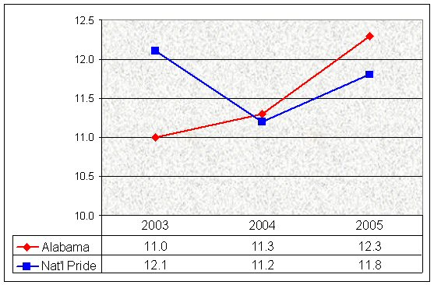
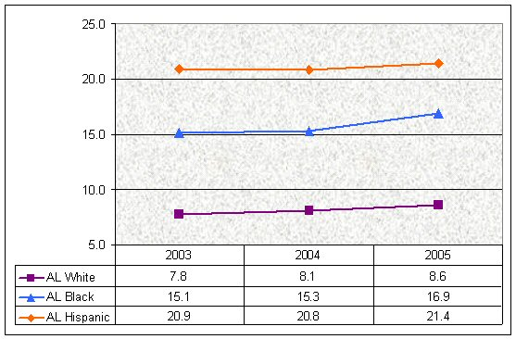

Figure 1.1 – Gang participation
Figure 1.2 – Alabama students: gang participation, by ethnicity

2. Carrying Guns

When asked about carrying guns, students answered whether they had ever carried a gun to school and if they had carried a gun outside of school “as protection or as a weapon.” The second question is asked to eliminate students who use guns outside of school for recreational purposes (eg, hunting).

Guns at school

Statistically significant differences emerged when comparing gun-carrying Alabama students with the rest of the Alabama student population. More than 62% who carried a gun to school said they had used an illegal drug in the past month vs a reported rate of 10.2% among the non-gun carriers. For physical bullying, 79.2% of gun-carrying students said they had hit, slapped, or kicked another student, while among the group of students who had never carried a gun to school, only 29.4% say they had hit, slapped, or kicked another student.

Violent impulses reported by gun-carrying students were also manifested in other violent acts. More than 28% of students who reported carrying a gun to school also reported that they had thought about committing suicide often or a lot. In contrast, only 6.1% of students who had never carried a gun to school reported the same.

In Alabama, the increased rate of students carrying guns to school is in contrast to the Pride Surveys national dataset, which reflects a trend showing no significant change over the same period. (Figure 2.1); gun-carrying behavior has increased in Alabama between 2003 and 2005 for the groups discussed in this report. (Figure 2.2).

White students were least likely to report carrying a gun to school, while Hispanic students were most likely to report doing so. However, due to the greater number of White students, more guns were with White students than with Hispanic students in schools. For example, in 2005, 3.4% of White students (N=129,969) reported carrying a gun to school, while 8.5% of Hispanic students (N=9,231) reported the same. In other words, approximately 4,400 guns were carried by White students and, approximately 780 guns were carried by Hispanic students.
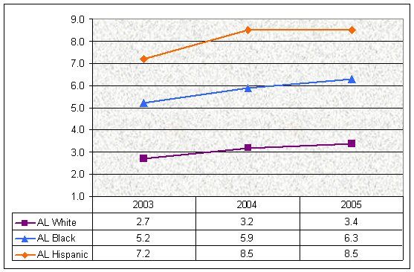
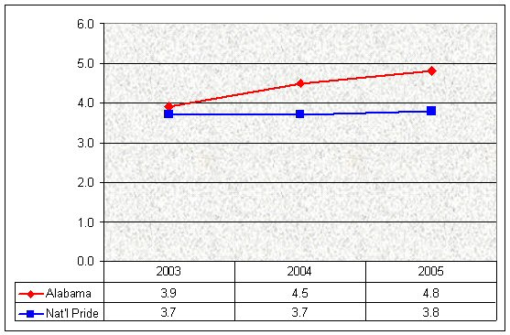

Figure 2.1 – Carrying a gun to school
Figure 2.2 – Alabama students: carrying a gun to school, by ethnicity

Guns outside of school

Homicides, drive-by shootings, and gun accidents occur more frequently in the community at-large than at schools. In 2004, the US Department of Justice reported that in every year from 1992 to 2002, students aged 12-18 years were more likely to experience a serious violent crime away from school than at school.⁶ In keeping, students in Alabama and across the country are far more likely to report carrying guns outside of school “for protection or as a weapon” than they are to report carrying a gun to school. (Figure 2.3)

Figure 2.3 – Carrying a Gun NOT at school
Figure 2.4 – Alabama students: carrying a gun NOT at school, by ethnicity

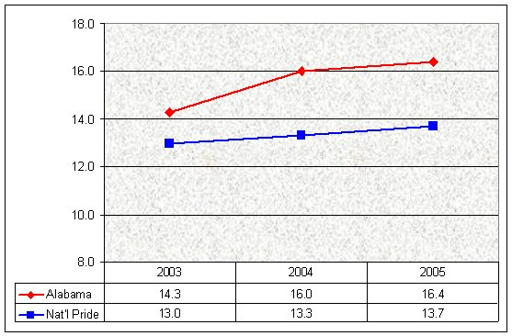
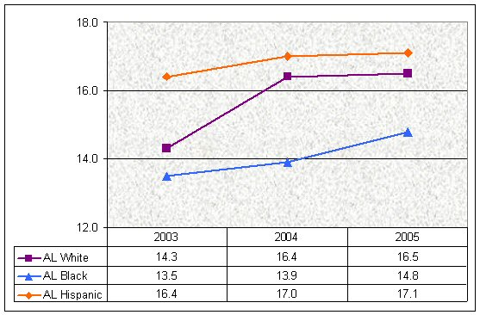
Nevertheless, an atmosphere of violence that prompts a student to carry a weapon takes its toll emotionally and academically. When compared with their peers, students who carried a gun outside of school were more likely to report suicidal thoughts (17.0% vs 5.4%) and never or seldom making good grades (11.0% vs 3.2%). Although this study reveals the correlation of these type of social issues, more detailed research is needed to determine the root cause of these factors and the effects they have on behaviors.

In Alabama, Hispanic students were most likely to report carrying a gun outside school. White students were next most likely to do so, and Black students were least likely. (Figure 2.4)

3. Threatening Behaviors

Alabama students were asked if they had ever threatened to hurt another student by hitting, slapping or kicking, and also if they had ever threatened another student with a gun, knife, or club. Both questions were combined to obtain the frequency of “threatening behaviors.”

Both in Alabama and across the nation, the rate of threatening behaviors is trending downward. In Alabama the rate has fallen from 41.0% of students reporting threatening others in 2003, to 37.9% in 2005, a relative decline of 7.6%. This rate of decline is slightly faster than the rate of decline found in the national dataset, which had a relative decline of 5.3%. (Figure 3.1)

Although some might say that violence, bullying, and threatening issues are not linked to drug and alcohol abuse, study data contradict this viewpoint. Of the students reporting “threatening” behaviors in the 2005 Alabama survey, 27.8% said that they had used marijuana in the past year and 41.9% reported using liquor, compared to the 10.4% and 20.9%, respective rates among “non-threatening” students.

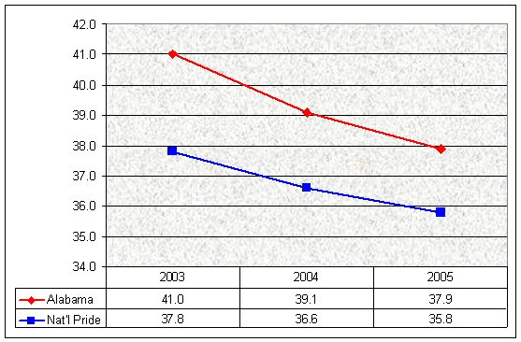
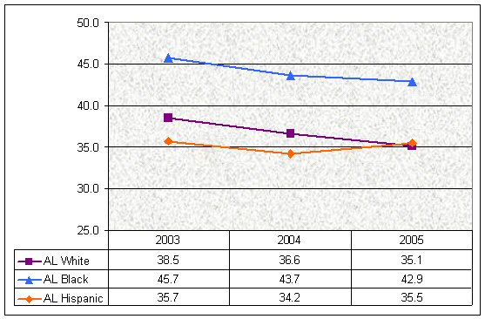
During the three years of Alabama’s survey, Hispanic students reported the lowest rates of threatening behaviors, with rates remaining relatively unchanged during the time period. At the same time, White and Black students showed a decline in reported rates of threatening behaviors. (Figure 3.2)

Figure 3.1 – Threatening behaviors
Figure 3.2 – Alabama students: threatening behaviors, by ethnicity

4. Fear of Being Hurt at School

On the Pride Questionnaire, one question reads, “While at school, have you been afraid that another student may hurt you?” For students in the Pride Surveys national dataset, the trend remained at similar rates during the last three years. In Alabama, the rate has declined from 23.7% to 21.7%. (Figure 4.1)

If this declining trend continues, it may also help decrease the incidence of students carrying guns to school. This study found that “fearful” students were more likely to report carrying a gun to school. Among all Alabama students in grades 6-12 in 2005, 4.8% reported carrying a gun to school. Of those who reported a fear of being hurt at school (21.7% of the study population), 10.7% reported carrying a gun to school.

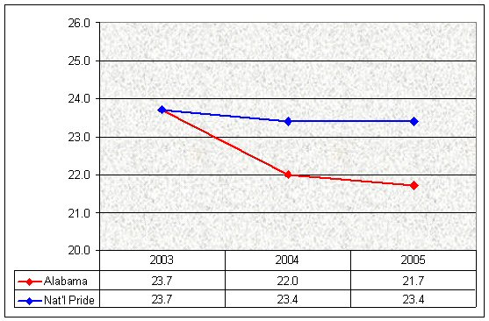
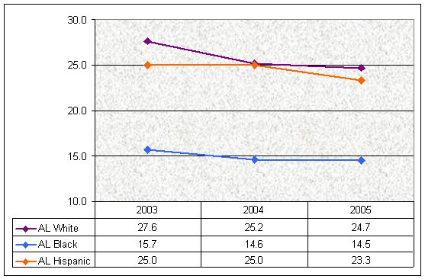
In reviewing responses from the three largest subgroups of the study population, all three groups showed a declining trend for “fear of being hurt at school.” It is interesting to note that, although few Black students report fear of being hurt at school (Figure 4.2), when asked if they feel safe in various locations on the school campus, Black students more frequently feel unsafe compared to their counterparts. (Figures 6.4-6.6)

Figure 4.1 – Fear of being hurt at school
Figure 4.2 – Alabama students: fear of being hurt at school, by ethnicity

5. Being Hurt at School by Another Student

Students were asked if they had been hurt at school by another student who hit, kicked, or slapped them. The reported rates of being hurt have declined both in Alabama and in the Pride Surveys national dataset and, again, Alabama has a greater relative percent decline in this comparison – 8.4% vs 5.8%, respectively. (Figure 5.1)

A word of caution: data from this survey indicate that the lines between being a “bully” vs being a “victim” may be quite blurred. Of those students who said that they had been hit, kicked, or slapped by another student, 71.0% said that they had also hit, kicked, or slapped another student. Of the students who had never been hit, kicked, or slapped, only 22.0% said that they had hit, kicked, or slapped another student.

White, Black and Hispanic students reported being hurt less frequently in 2005 than in 2003. Hispanic students were the most likely to report being hurt by another student in all three years, while Black students were least likely to report being hurt. (Figure 5.2)

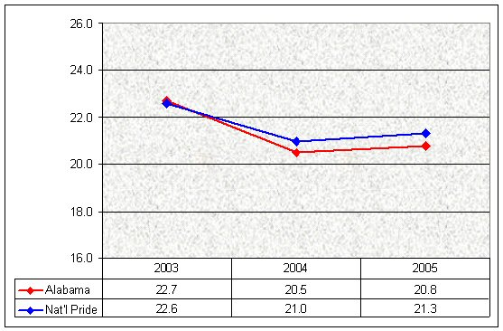
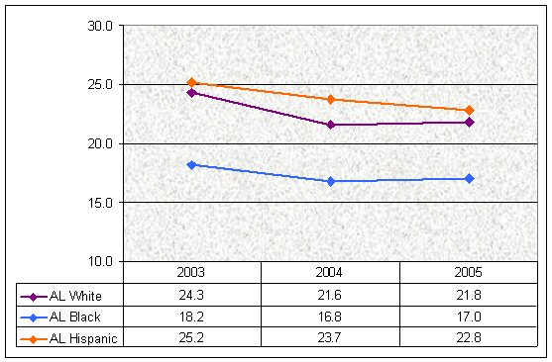
In most cases, more students reported being afraid that another student would hurt them than having actually been hurt by another student. For Black students, the reverse appeared to be true, perhaps indicating that some students who have been hurt at school still claim that they do not fear being hurt at school.

Figure 5.1 – Being hurt at school by another student
Figure 5.2 – Alabama students: being hurt at school by another student, by ethnicity

Safety and Fear

In the three surveys administered during 2003 - 2005, students were also asked to rate their feeling of safety in various locations in their schools. For each location, students could answer that they felt safe never, seldom, sometimes, often, or a lot. The greatest number of students reported feeling safe in the classroom (Figure 6.1), while fewer students said they felt safe in the parking lot. (Figure 6.2) More adult supervision seems to help students feel safer.

Regardless of location, Alabama students reported feeling less safe over the three years in all areas of the school. In 2005, nearly a quarter of Alabama students reported that they never felt safe in the school parking lot. Meanwhile, the trend in the Pride Surveys national dataset showed little change for the same time period.
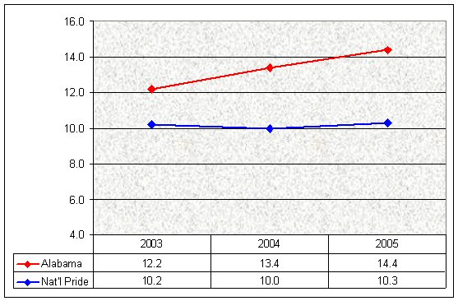
Figures 6.1 - 6.6 illustrate the responses of the students who say they never feel safe in a given area. As noted previously, these students are likely to be more at-risk for academic underachievement, depression and other emotional problems, as well as truancy and dropping out of school.¹⁻⁴

Figure 6.1 – Never feeling safe in the classroom

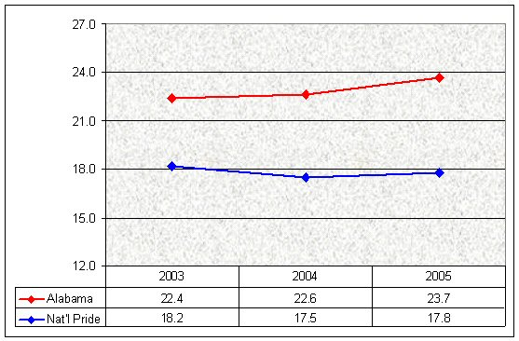
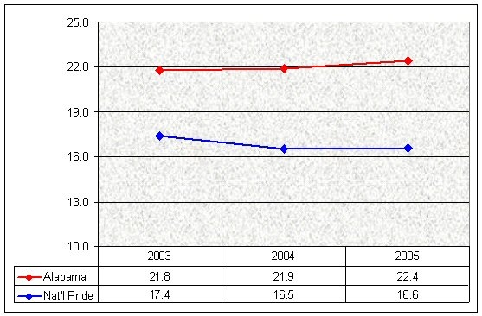
Figure 6.2 – Never feeling safe in the parking lot
Figure 6.3 – Never feeling safe on the school bus

In the past few years, much attention has been focused on violence and bullying on school buses. As a result, several programs have been put into place to help supervise students on the buses and reduce the bullying that may occur there. In the Pride Surveys national dataset, students are feeling safer on the school bus compared to Alabama students. (Figure 6.3)

The influence of ethnicity

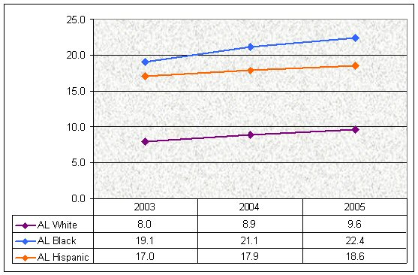
Black students consistently reported feeling least safe in all school areas, followed by Hispanic students and White students. (Figures 6.4-6.6) This finding seems to conflict with the students’ earlier answers. While Black students reported they were less afraid of being hurt or that they had been hurt, they also reported they felt safe less frequently than their White or Hispanic counterparts. Research is needed to determine if and how ethnicity is related to these attitudes and perceptions.

Across ethnic groups, the trend of more students never feeling safe in varying school locations held true; each group felt schools had not become safer in the past three years.

Figure 6.4 – Alabama students: never feeling safe in the classroom, by ethnicity

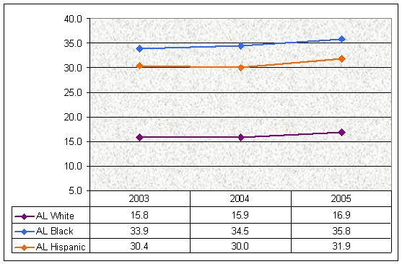
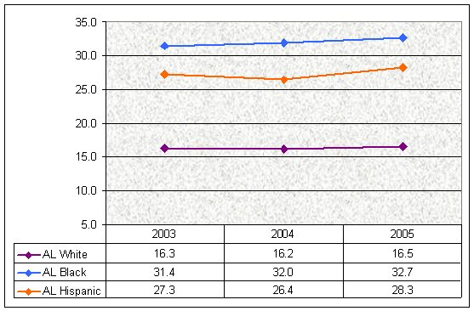

Figure 6.5 – Alabama students: never feeling safe in the parking lot, by ethnicity
Figure 6.6 – Alabama students: never feeling safe on the school bus, by ethnicity

CONCLUSION

When Alabama students first took the Pride Questionnaire in spring 2003, the data provided a snapshot of students’ attitudes and experiences about bullying, threatening behaviors, and violence in school. When data from the surveys in 2004 and 2005 are compared to that first survey, trends begin to emerge.

The good news from such a comparison is that some factors surrounding the school environment are improving. Over the years from 2003 to 2005, fewer students reported: being afraid (23.7% vs 21.7%, respectively); threatening behaviors (41.0% vs 37.9%, respectively); and being hurt at school (22.7% vs 20.8%, respectively).

Despite this good news, in the eyes of Alabama students, school is becoming a more frightening place and students seem to be more afraid than their peers across the nation. More Alabama students are reporting being involved in gang activities and bringing weapons to school than their national peers. This atmosphere of fear decreases the faculty’s teaching effectiveness and the students’ ability to learn.

Although this study reveals what students were doing and feeling, it cannot determine why they did or felt as they reported. More research is needed to investigate what might be causing the recent increases in student perception of violent, threatening and bullying behaviors. One of the central questions to be addressed is why more students said they were feeling unsafe, while at the same time, fewer students said that they had been hurt or feared being hurt at school.

Schools are historically a safe haven for children. It is important to determine the causes of bullying and violence at school in order to improve and implement more effective programs so that Alabama students will feel safer at school.

Appendix. Study Population and Pride Surveys National Dataset, 2003-2005

Alabama Student Population, Grades 6-12
N
- Alabama – 2003 247,237
  - White 149,389
  - Black 78,310
  - Hispanic 4,302

- Alabama – 2004 262,050
  - White 160,072
  - Black 79,104
  - Hispanic 5,468

- Alabama – 2005 263,944
  - White 159,674
  - Black 79,882
  - Hispanic 6,131

Note: Ethnicity is self-reported as students select from one of the following: White, African American, Hispanic/Latino, Asian/Pacific Islander, Native American, Mixed Origin, or Other. In this table, only data for White, Black and Hispanic are shown since other ethnic groups were a small minority and were not the subject of this report.

The National Pride dataset is compiled each year by combining data from students in Grades 6-12 in schools around the country. This annual summary uses a weighting system for states that conduct state-wide surveys and states where relatively large numbers of school systems use the Pride Questionnaire, so that no state has a disproportionate influence on the overall summary. Random samples are drawn from states that surveyed large numbers of students; no one state comprises more than 10% of the total data in the summary. For comparison purposes in this report, only White, Black and Hispanic data are shown.
- Nat’l Pride Summary – 2003 109,919
  - White 72,035
  - Black 19,668
  - Hispanic 7,237

- Nat’l Pride Summary – 2004 114,402
  - White 76,128
  - Black 20,140
  - Hispanic 5,940

- Nat’l Pride Summary – 2005 193,658
  - White 129,969
  - Black 32,954
  - Hispanic 9,231

Specific reports were generated for this project, in which the data was divided by students’ responses to a specific question. Responses of the two groups of students were then compared. The populations of the subgroups were as follows:
- Alabama 2005 – Took Part in Gangs 31,836
- Alabama 2005 – Did Not Take Part in Gangs 227,035

- Alabama 2005 – Carried a Gun to School 11,808
- Alabama 2005 – Did Not Carry a Gun to School 232,148

- Alabama 2005 – Carried a Gun NOT at School 42,396
- Alabama 2005 – Did Not Carry a Gun Outside School 216,180

- Alabama 2005 – Hit, Slapped, or Kicked a Student 77,379
- Alabama 2005 – Did Not Hit, Slap, or Kick a Student 165,456

- Alabama 2005 – Hit, Slapped, or Kicked by a Student 48,558
- Alabama 2005 – Never Hit, Slapped, or Kicked by Student 194,032

References

- Massey MS. Early childhood violence prevention. ERIC Digest. Available at: http://www.eric.ed.gov/ERICDocs/data/ericdocs2/content_storage_01/0000000b/80/2a/2c/30.pdfLast accessed: January 27, 2006.
- Heinrich CC, Schwab-Stone M, Fanti K, Jones SM, Ruchkin V. The association of community violence with middle-school achievement. Applied Developmental Psychology. 2005;25: 327-348.
- Cole SF, O’Brien JG Gadd MG, Ristuccia J, Wallace DL, Gregory M. Helping Traumatized Children Learn. Massachusetts Advocates for Children, Boston, MA. Available at: http://www.massadvocates.org/helping_traumatized_children_learn. Last accessed: January 26, 2006.
- Lorion RP Exposure to urban violence: contamination of the school environment. In eds: Elliott DS, Hamburg B, Williams KR. Violence in American Schools: A New Perspective. New York, NY: Cambridge University Press. 293-311.
- Metze L. The Pride Questionnaire for Grades 6-12: Validity and Reliability Study. Western Kentucky University, Bowling Green, KY. Available at: http://www.pridesurveys.com/main/supportfiles/tr99612.pdf. Last accessed: January 25, 2006.
- US Department of Justice (2004). Crime Characteristics. Available at: http://www.ojp.usdoj.gov/bjs/cvict_c.htm. Last accessed: January 19, 2006.

